Getting to Know Alma
Activating an Electronic Collection

This document includes two exercises that review what you learned in the Activating an Electronic Collection session, including locating and activating an electronic resource from the Community Zone.

In these exercises you will need to be logged into your Alma sandbox environment and have cataloging privileges.

The first exercise will walk you through how to activate and Electronic Collection from the Community Zone.

Activate an Electronic Collection from the Community Zone
- In the persistent search bar at the top of the page, change the search type to Electronic Collection and the search scope to Community, then enter a keyword or title for the collection you want to activate.

- Click the magnifying glass to search.
- On the results page, find the collection you want, and click the Activate button. If you don’t see it as a button, you may need to open the Record Actions menu  and find it in the drop-down menu. | 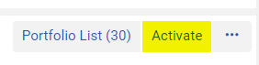
- When you click Activate, the Activation Wizard will open. This exercise will walk you through the basic sets. You can find more information about how to complete the wizard in the Knowledge Center.  - In the Full Text Service section, check Activate this electronic collection service, this will activate the collection for your institution.  - Click Next. | 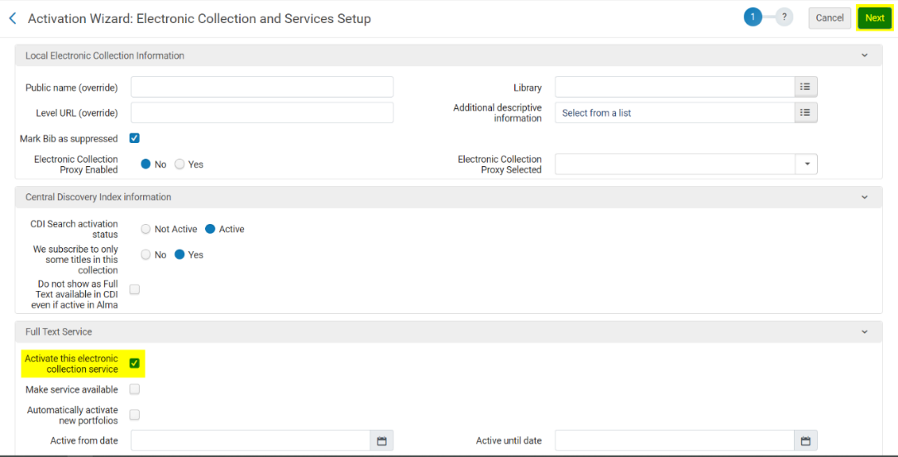
- In the second step, leave the Proxy enabled selection as No. The proxy allows you to identify a proxy profile to use for authentication of users outside the library’s network.  - Click Next. | 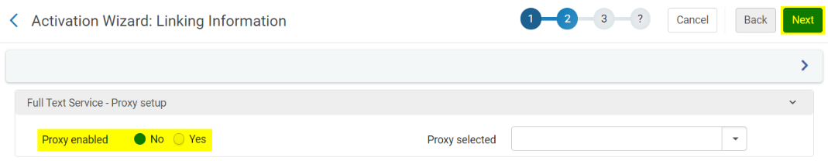

- In the third step, for the Activation Type, select the first option to Activate all. The other options here will allow you to select what parts of this collection you want to activate.  - Click Next. | 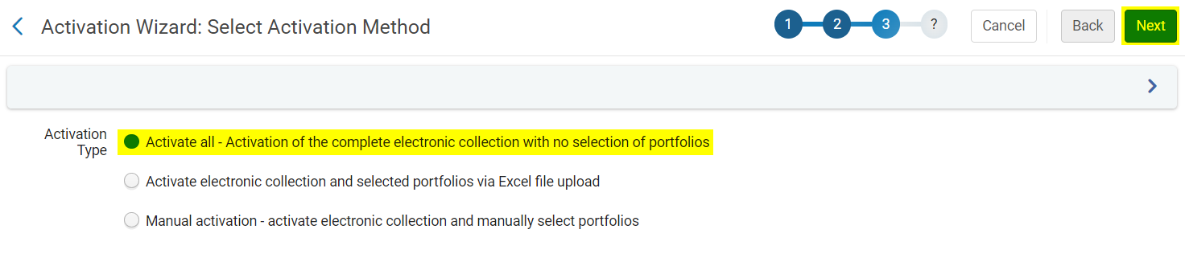
- The fourth step provides a summary of the service you are activating. Click Activate.  An activation job has now been created and an email will be sent when it is completed. | 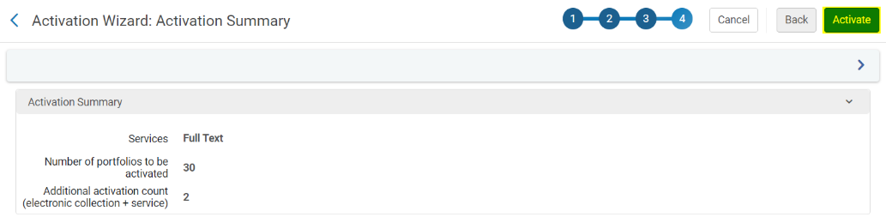
- To see the job, go to Admin > Monitor Jobs. | 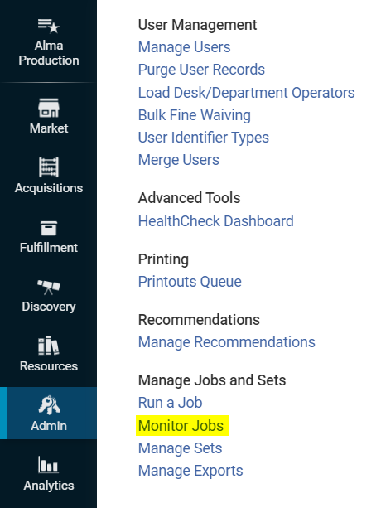
- The job will be listed in the Running tab. If you don’t see it here, it may have already finished. Skip to step 15.  - Click Refresh to check the progression of the job. | 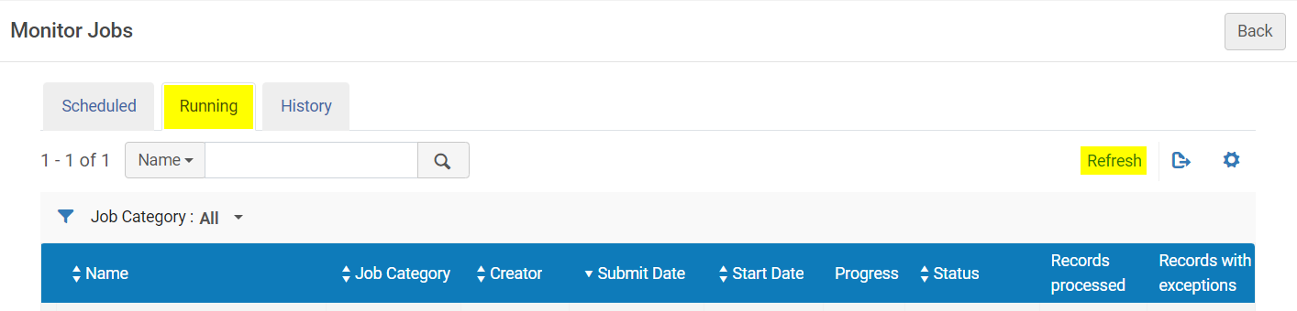
- Once it is finished, click the History tab to confirm that the job completed successfully. | 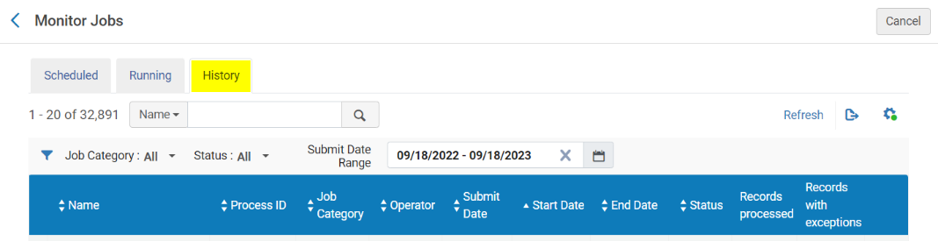
The collection has now been activated! More information on the next steps can be found in the documentation.

View an Electronic Collection
In this exercise you will locate the electronic collection that you just activated in your catalog; and then open it in the MD Editor.

- In the persistent search bar at the top of the page select the Electronic Collection index. You can then change the search field to Title and enter the title of the collection you just activated; and change the search scope to the Institution Zone.

- Click the magnifying glass to search.
- On the results page, you can use facets to narrow your search further.  - Once you find the collection, you view the contents of the collection by clicking Portfolio List. The number in parentheses is the number of portfolios within the collection. | 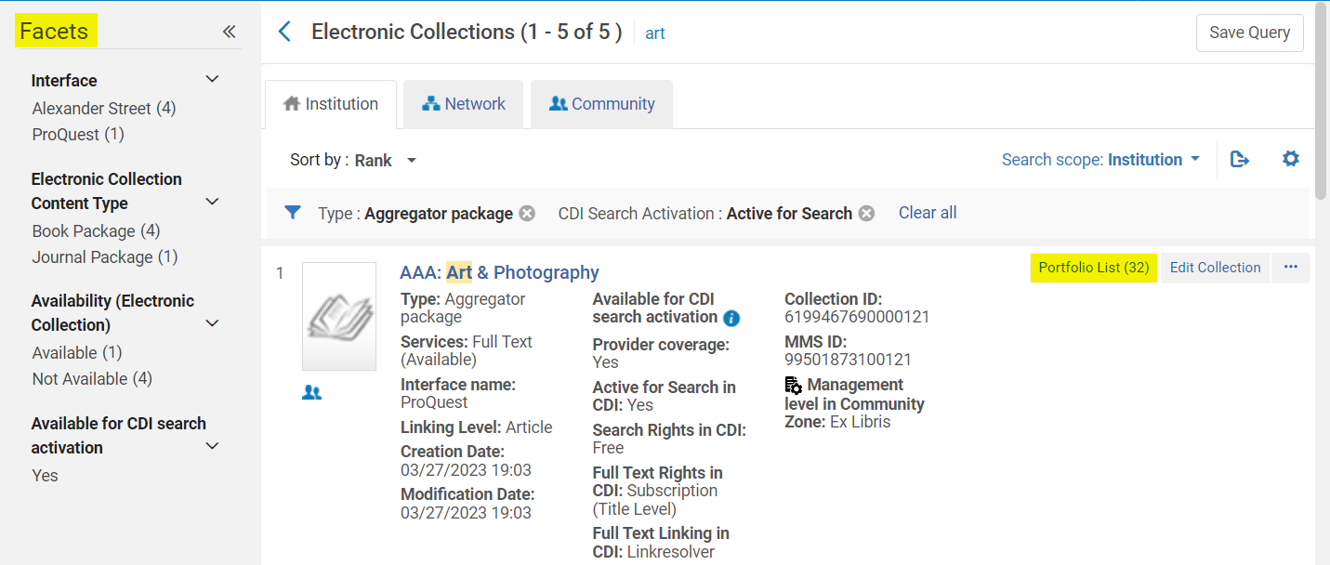
- Click the Back button if you viewed the list of included portfolios; otherwise, skip to the next step.  - To view the bibliographic record for the collection, open the Record Actions menu and select Descriptive Record. | 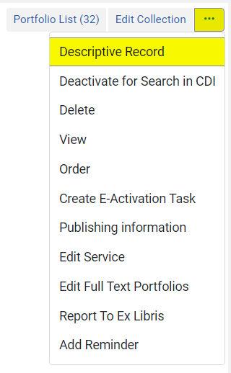
- This opens the Record View. To make changes click Edit in the top right corner of the panel to open this record in the MD Editor. | 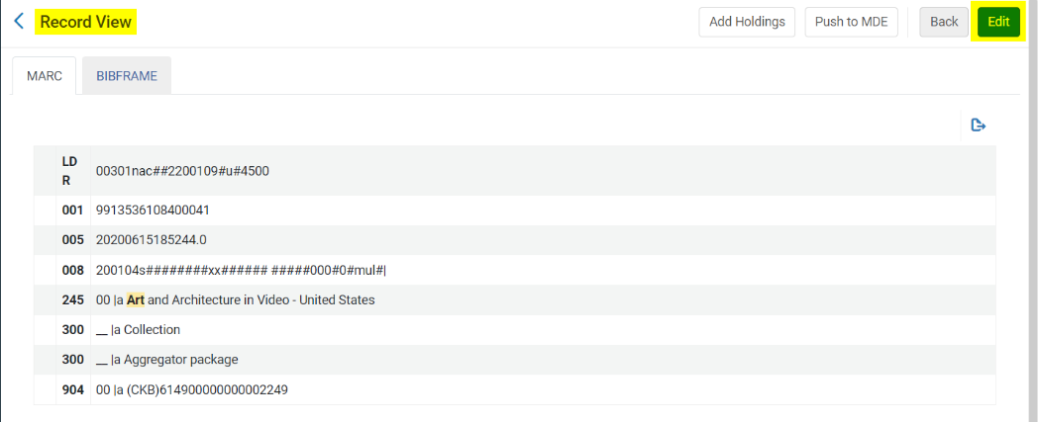

- You cannot make changes to this record because it is linked to the Community Zone and the Editing Actions menu at the top of the page is grayed out. If you want to create your own copy for your institution, click Record Actions, and then select Copy to Catalog.  - You can now edit this record as needed. However, please note that you will not receive any updates to the record from the Community Zone because this is now a local record.  - Click Save when you’re done. | 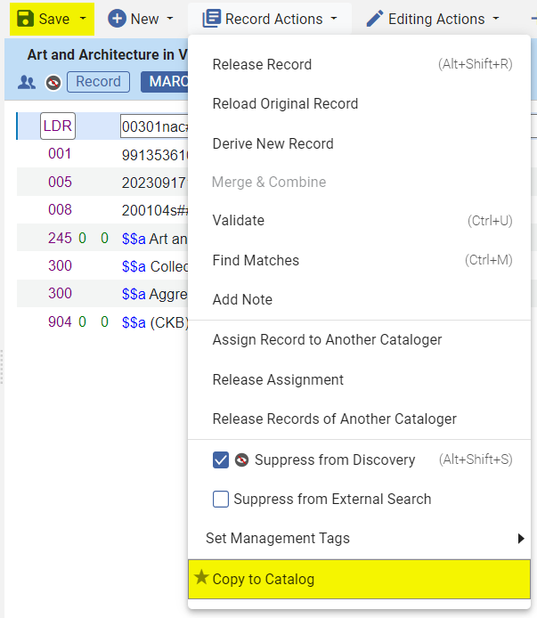

- To release the record, click Record Actions and select Release Record. | 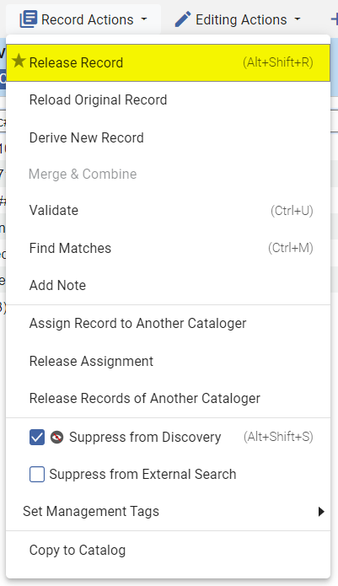
The record has now been copied to your catalog and released!

