Getting to Know Alma
Acquisitions Overview

Purchasing a Physical Item (Book)
- Search for a physical title in your Institution Zone
- Locate the title in the results and select Order from the Record Actions menu | 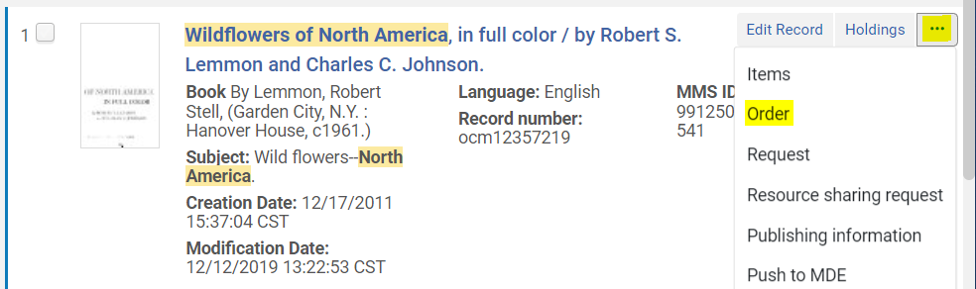
- Set the PO Line type = Print Book – One Time  - Set the PO Line Owner = Main Library (or whichever library will own the item)  - Click Create PO Line | 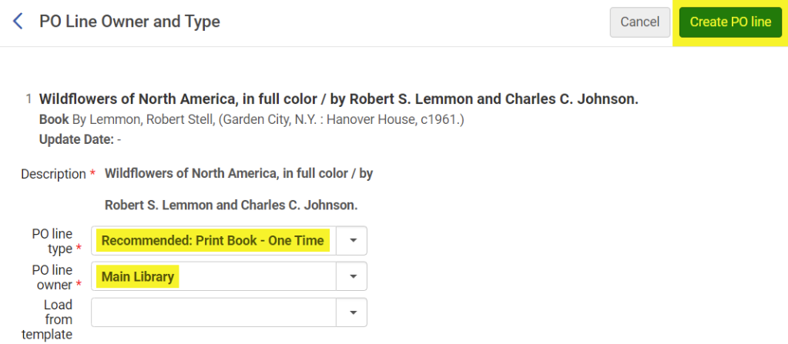
- Note that the Confirmation Message will say that the resource already exists in the inventory  - Click Confirm to create the PO Line | 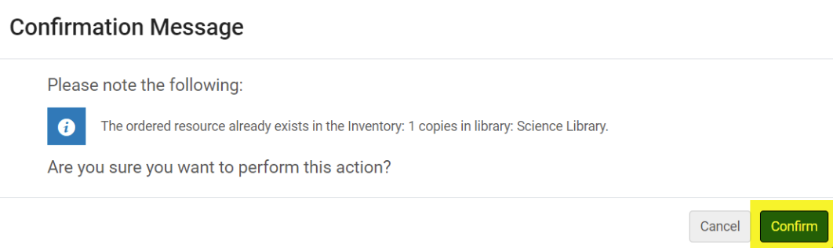
The PO Line has been created! More information on the next steps can be found in the documentation. | 