Getting to Know Alma
Advanced Searching

Search with Multiple Parameters
- Click the advanced search icon to open the advanced search pane. | 
- Search in Physical items. | 
- Use the first row to craft your first parameter. Select Holdings: Library (Holdings), Equals, then select a library. | 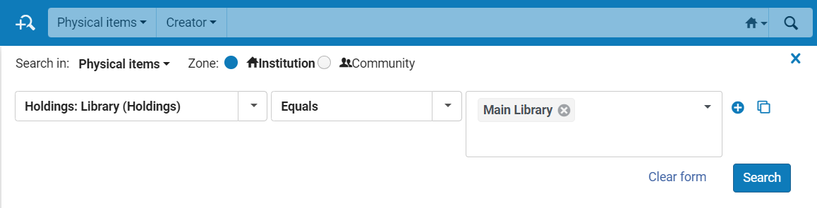
- Click the plus sign to add a row. | 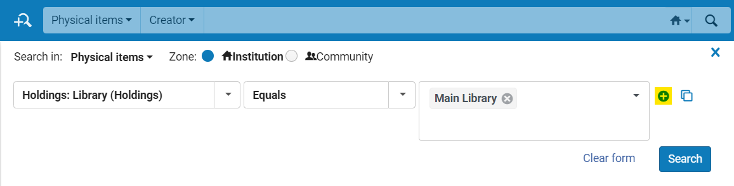
- Enter the next parameter: AND, Title: Keywords, Contains Keywords, then type a keyword of your choice.  - Add more parameters if you want, then click Search. | 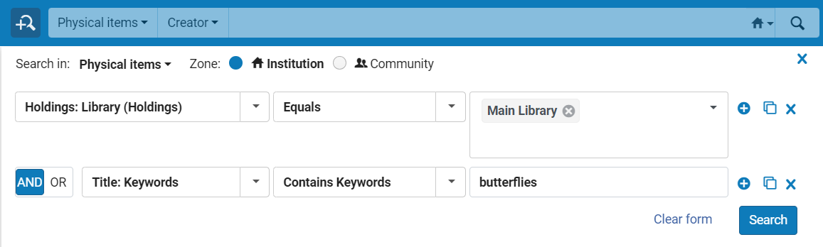
- View the results of your advanced search. | 