Getting to Know Alma
Loans

This document includes two exercises that review what you have learned in the Fulfillment sessions, including how to check out and renew physical items, as well as how to return an item.  For both exercises, you will need to be logged into Alma and have Fulfillment privileges and set your location as the Main Library – Circulation desk. |  | 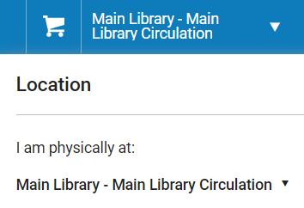
Check Out & Renew Physical Items
In this exercise, you will be checking out a physical item to a patron and learn how to renew an item that is checked out on a patrons account. To complete this exercise, you will need:
- An active patron account
To find a patron account, on the left-hand menu go to Admin > Manage Users. Click the Public tab and select a patron that has an account that is not expired. Write down their first and last name.
- At least 1 barcode for a physical item
To find an item in the catalog do a Physical Item: Keyword search in the persistent search bar. Copy the Barcode from an item that has a status of Item in place.
- On the left-hand Navigation bar, go to Fulfillment > Manage Patron Services. | 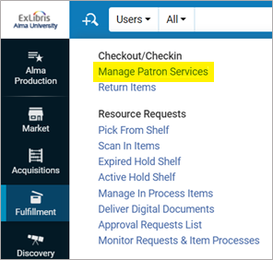
- There are two options for entering a patron in the Scan patron’s ID or search for a patron field:  - Type in at least the first 3 characters of the patron’s name that you just chose.  - Click the Select from a list 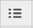 button and search for a patron in the pop-up.  - If you already entered a patron name, go to the next step, otherwise click on the name of the patron you would like to check out an item to from the list in the pop-up.  - Once you have the patron’s name entered in the patron ID field, do not check Use proxy, click Go. | 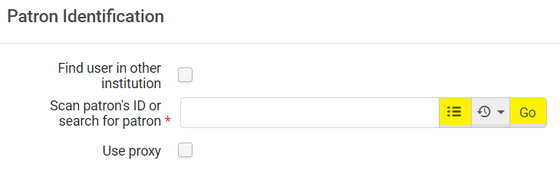

- In the Patron Services screen, enter the barcode for them item you previously selected or search for it by clicking the Search from a list button.  - If you entered a barcode skip to the next step; otherwise, click on the item to select it.  - The barcode should now be in the Scan item barcode field. Save this barcode number for the next exercise on how to return an item. Click OK. | 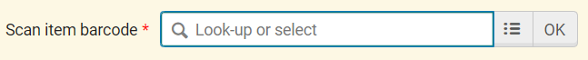
- The item has now been checked out to the patron. To see the options to Renew the item or Change Due Date click on the Actions menu (…) | 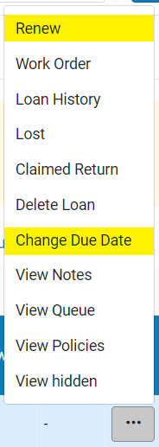

- Click Done in the top right to close the patron record. | 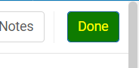
The item has been checked out! More information can be found in the documentation.

Return Physical Items
In this exercise you will be returning a physical item. To complete this exercise, you will need:
- At least one barcode for an item that has been checked out. We recommend using the barcode that you checked out in the Checkout & Renew Items section.

- On the left-hand menu bar go to Fulfillment > Return Items | 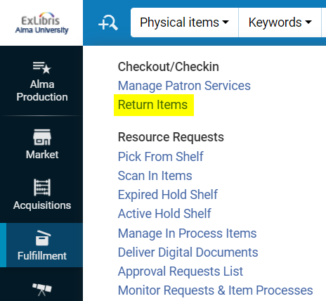
- Enter the barcode number you used in the Checkout & Renew Items exercise in the Scan item barcode field. If you don’t have an item you can search for it using the Select from a list button to search for an item to return.  - Once the item barcode has been entered into the barcode field, click OK. | 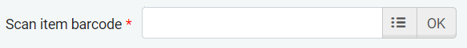
The item has returned! Repeat for any additional items. More information can be found in the documentation.

