Getting to Know Alma
Searching in Alma

Searching by Author
- In the Search Bar at the top of the screen, select All titles, then Creator. | 
- Type the name of an author. Select Institution Zone. Click the Search icon or press Enter. | 
- Notice the results in the center and the search Facets on the left. | 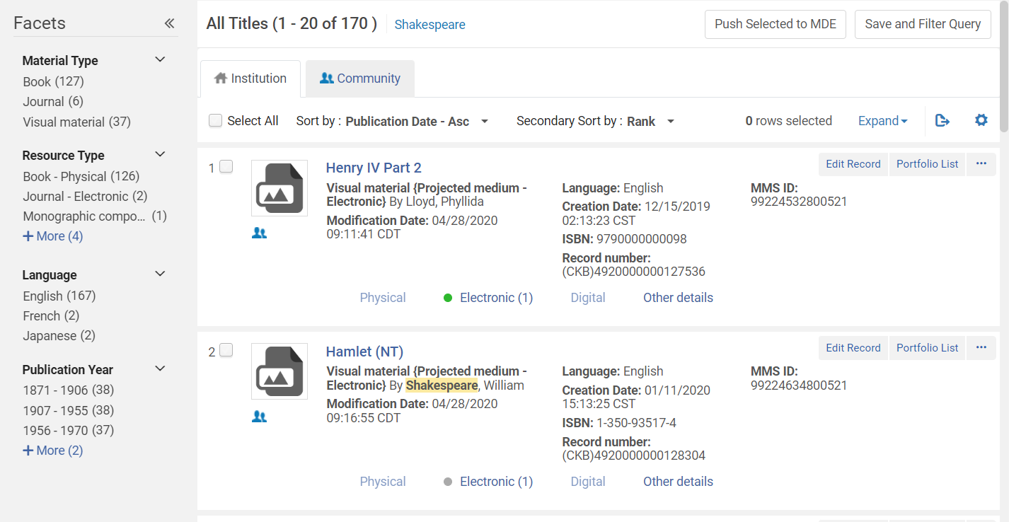
- Select a Facet to narrow your search. | 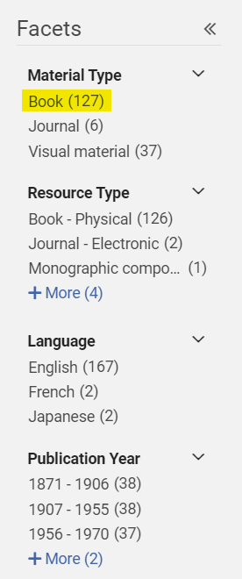
- Select the Community tab to see resources available in the Community Zone. | 