App Store Listing
Ex Libris campusM Configuration Form

Overview
Your campusM app will be a white-label app and appear in the app stores under the institution developer account with your app name and branding.
The App Store Listing is used when the app is submitted to Apple and Google stores for approval, and contains all the formal information needed to submit the app, such as: app name, app long name, keywords, app description, etc.
During the activation, your campusM team will submit the app to the Apple and Google stores for approval using the institution developers account and the information in this form.

Complexity Level | Medium
Customer Owner | Marketing, Communications, Student Affairs (typically)
Required for activation | Yes, can be updated during post-activation and post go-live
More information

RECOMMENDATIONS
✓ Search Keywords | ✓ Unique App Name | ✓ Unique Icon

your APP STORE pages
Please provide the information that you would like to display in the iOS and Android store listing pages for your app. For each category please provide the relevant value.

Branding Option | More Information | Value
Application Name | - 12 Characters max  - Unique on App Store
Application Long Name | - 30 Characters max  - Unique on App Store
Short Description | - 80 Characters max  - If applicable, an English translation below original
Developer Name | - 30 Characters max
Application Description | - 4000 Characters max  If applicable, an English translation below original  - Do not include: beta, testing, demo, etc.
Search Keywords | - 100 Characters max  - Comma Separated  - Do not include: beta, testing, demo, etc.
Test user | - Working Login Credentials (Username & Password)  - Required for screenshots and app submissions  - Must be set up to show what a user will see, no beta content
Primary Category | - iOS - Defaults to Education  - Android - Set as Application and should not be changed
Secondary Category | - iOS - Not used by default  - Android - Set as Education and should not be changed
Application URL | - Usually main website
Support URL | - Can be specific support website or main website
Privacy Policy URL
Support Email | - for Apple use, not seen by end users

iOS Store Page

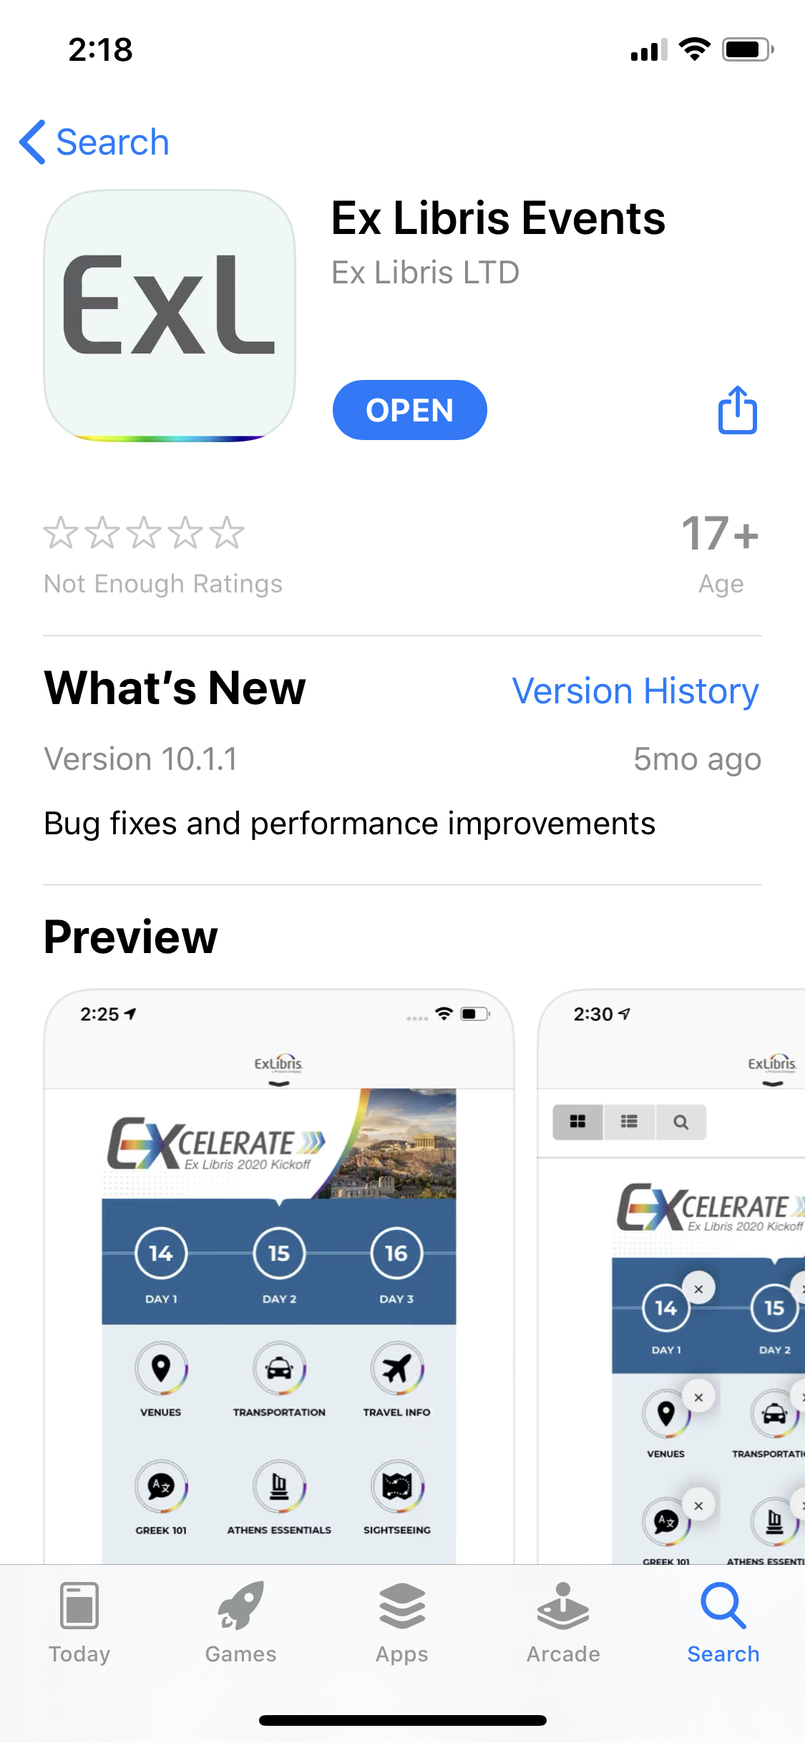
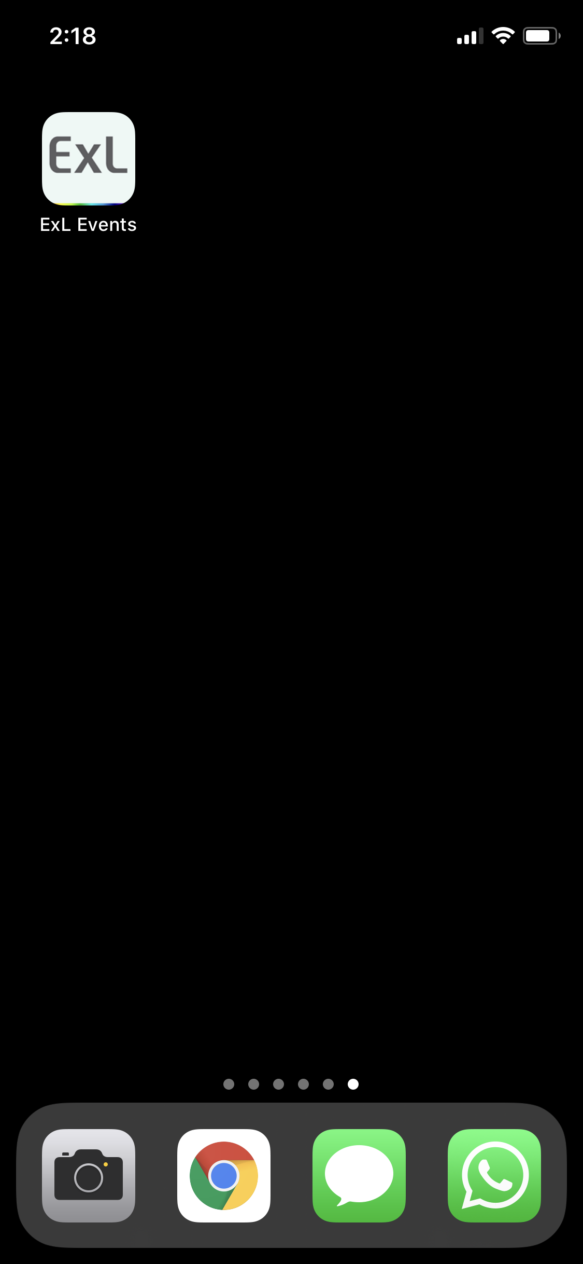
Application Long Name
App Icon

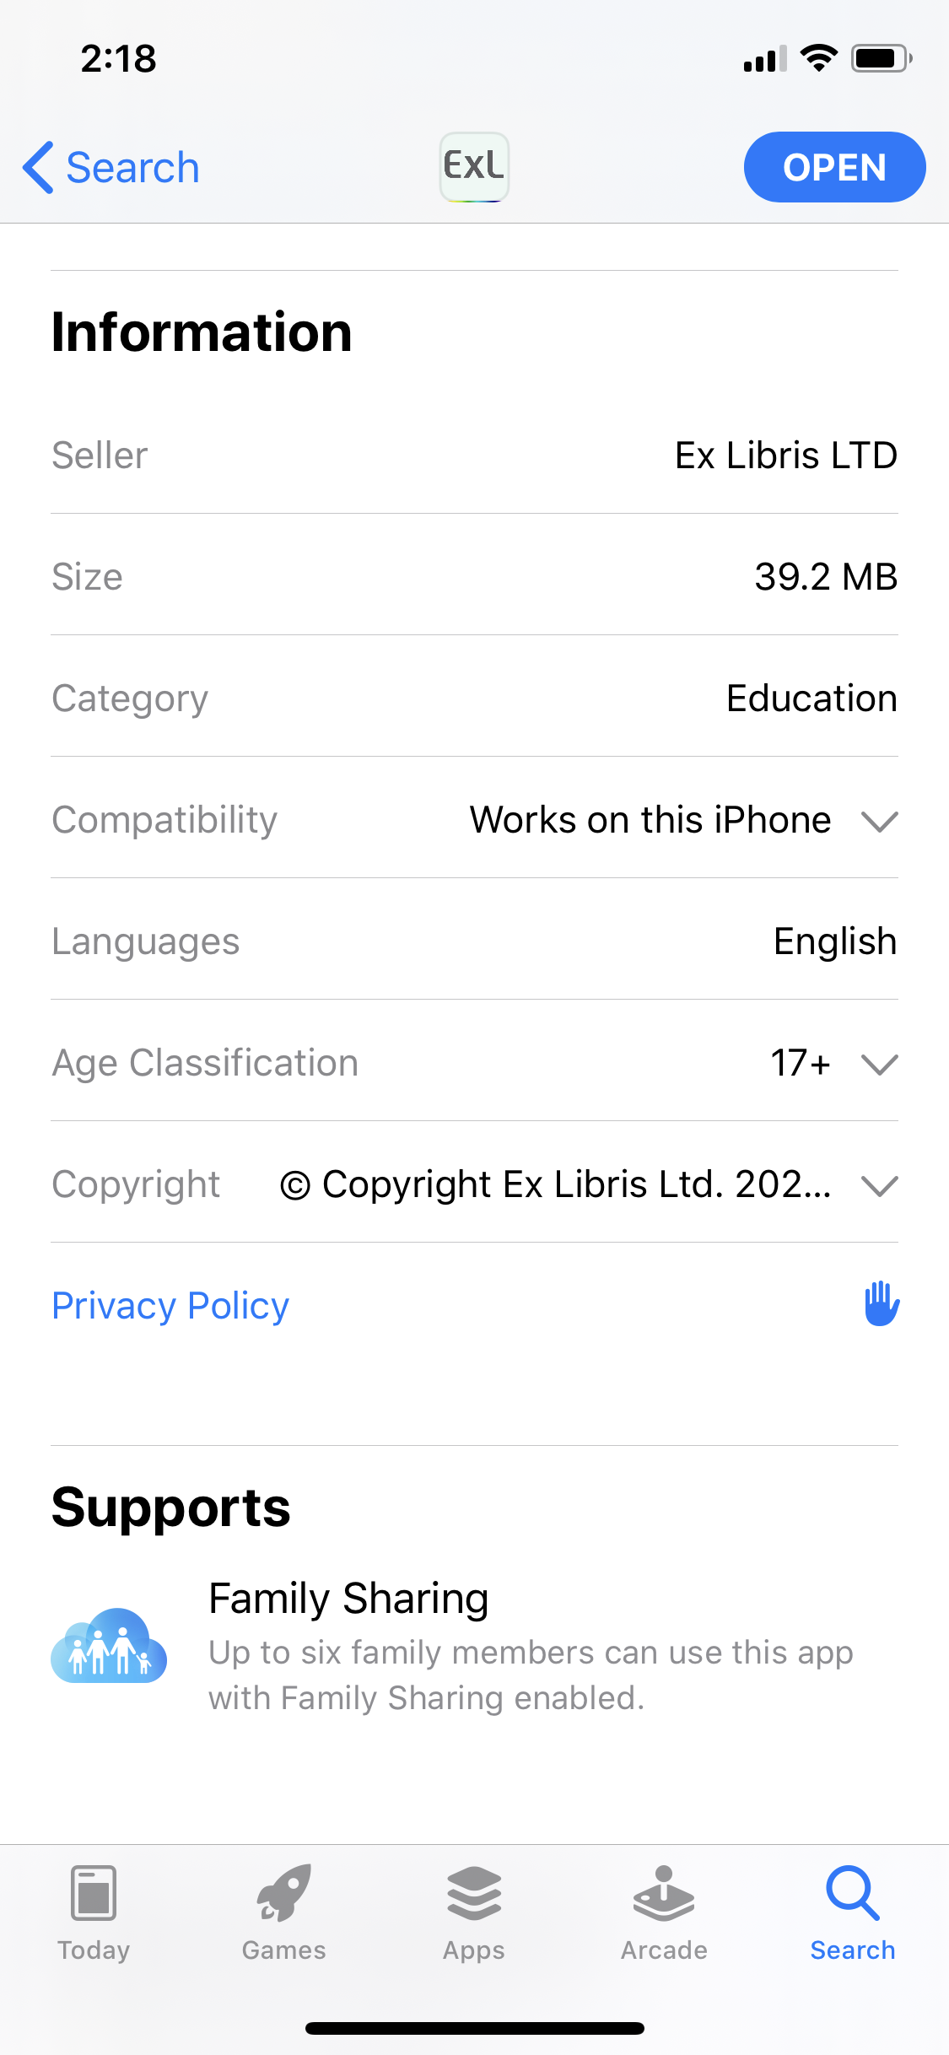
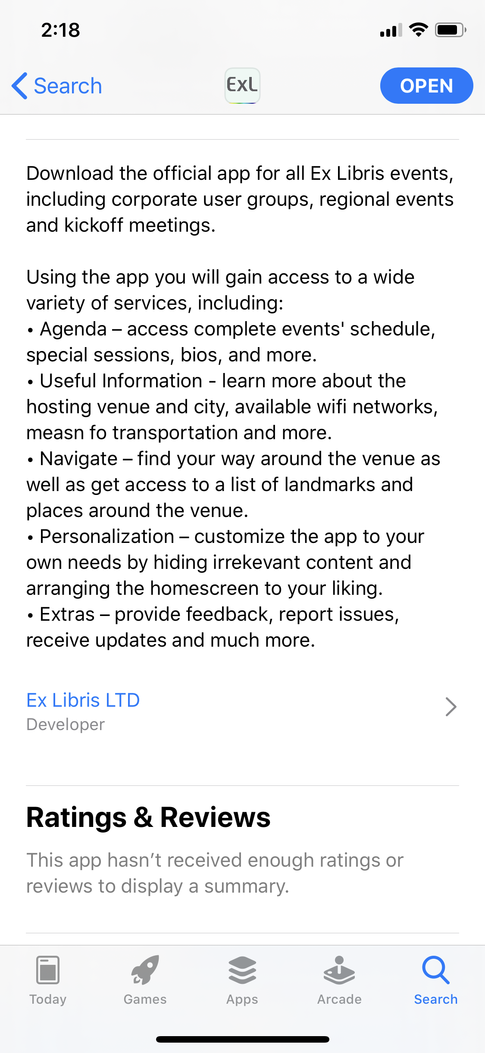
Application Description
Application Name
Developer Name
What's New
Primary Category
Privacy Policy URL

ANDROID Store Page

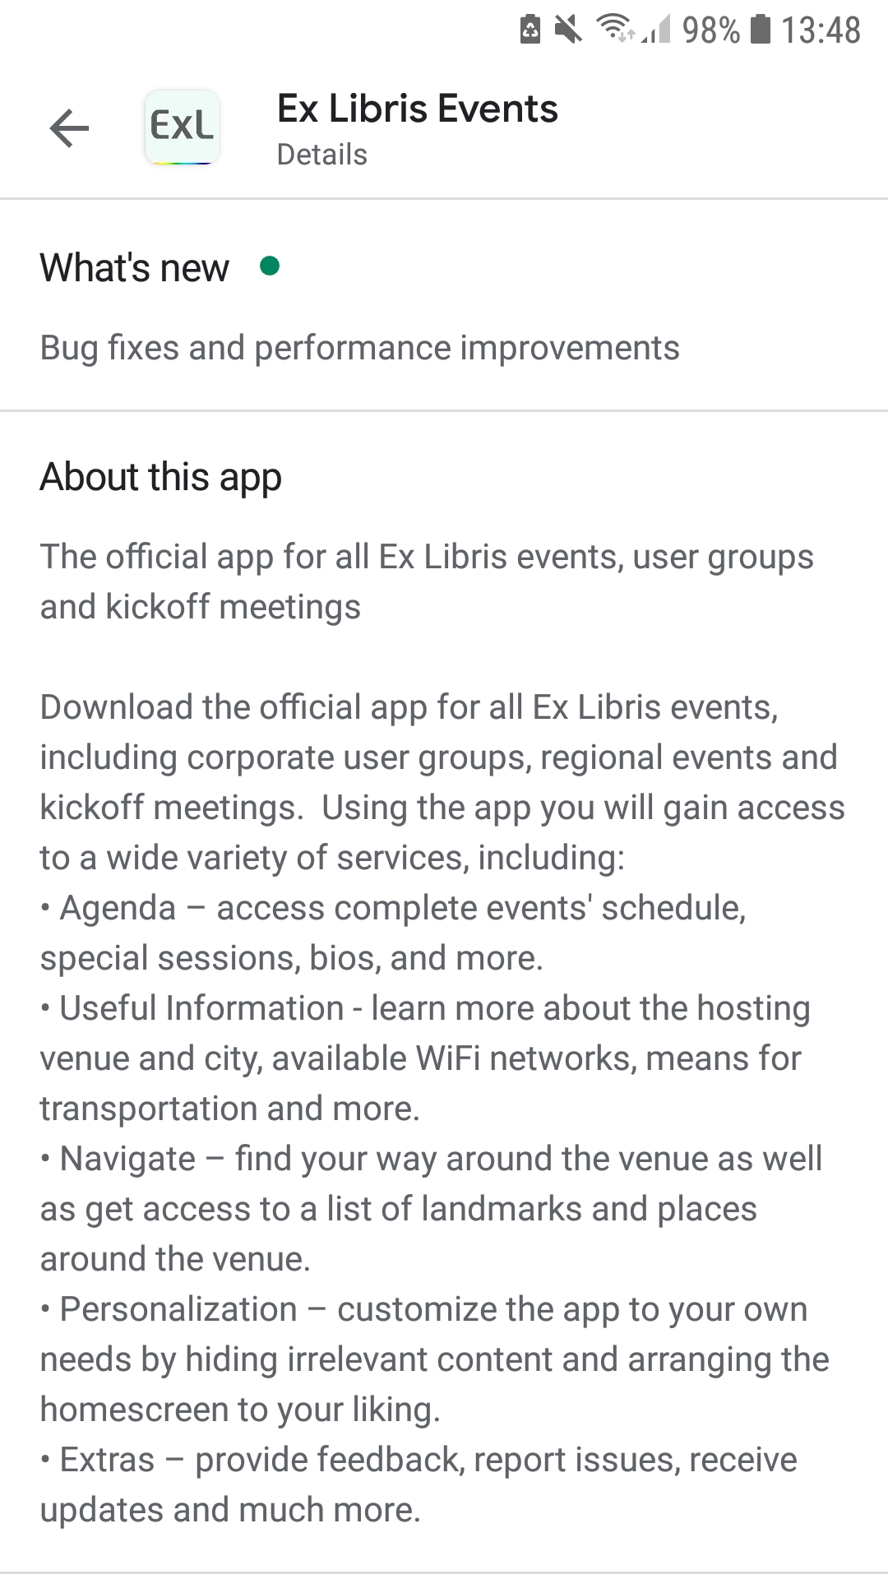
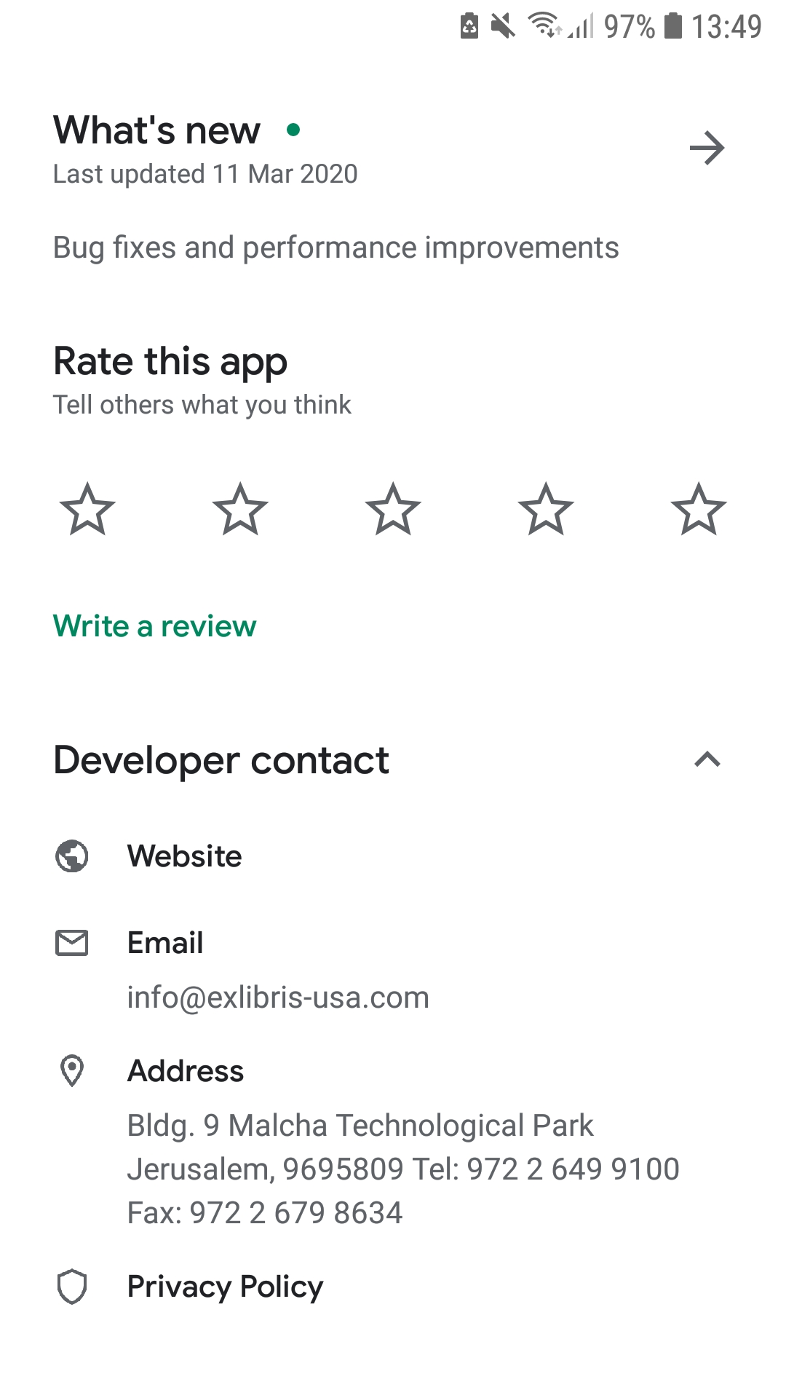
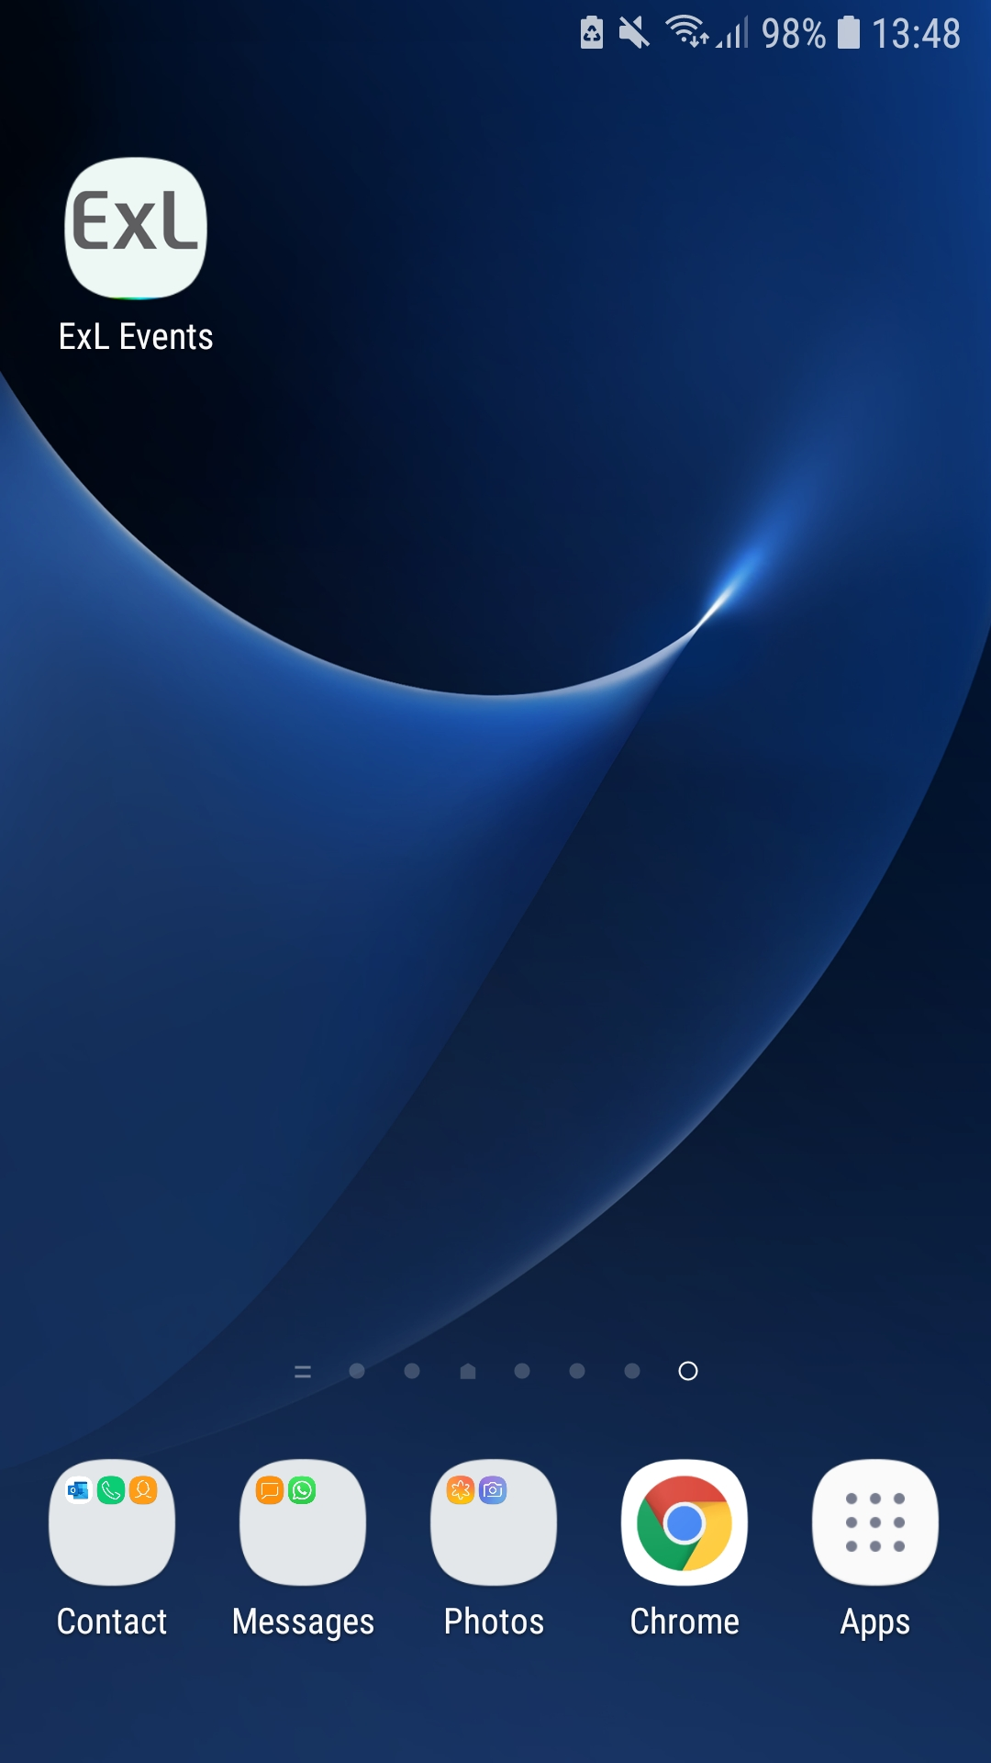
Developer Details
Application Name
Application Description
Application Long Name
App Icon
Privacy Policy URL
What's New
App Short Description

