Deep Links

Script | Direction
campusM deep links allow you to link from outside the app into a service or area within the app.  This opens up many possibilities to increase engagement with the app. You could, for example, send an email with a link to a Quick Poll inside the app; or place a QR code at the campus entrance on open day with the location of the relevant lecture hall.  The deep link opens the app directly to the specified page. If the app is not installed, or if the link is accessed on a desktop, the link opens the campusM webapp using the device’s default browser. | Intro  Show an email with a link to a poll, and a QR code on campus. Show the link opening a location.  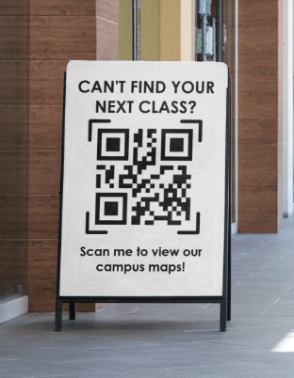
You can obtain a deep link in various ways, depending on the desired page in campusM.  The precise instructions on how to build these URLs can be found in the campusM documentation under Appendixes > Working with App URLs > Using deep links to a Service or an Area in the app. This table explains how to obtain a link for each area of campusM.  The general structure of the deep link is your campusM URL / campusM / deeplink, followed by a question mark and URL parameters. The parameters differ by the desired target. | Deep Link Structure  Show the documentation  Callout showing a deep link.
Let’s look at some examples:  To link to the App Feedback section in the App Settings, use the URL parameter “feature=feedback”.  For the Calendar service, the parameter is “feature=calendar”.  For Events, use the parameter “feature=events” followed by an assigned instance parameter. You can find the instance by editing the desired Events Product Integration in App Manager, and looking at the last part of the URL in your browser.  For a Map Location, use the parameter “feature=uniloc” followed by an assigned posCode parameter. To get the location code, open the location for editing, under App Settings > Maps/Locations > Positions, and copy the location code from the last part of the URL.  The rest of the examples can be found in the table in the documentation. | Examples  As described
Finally, you may wish to convert a deep link into a QR code which students can scan with their phone. This can be done in one of many free online tools, such as Bitly or QR Code Monkey. | QR Code Generation
With deep links, you can prompt your end-users to go into the app, and get the information they need easily, and from anywhere!  Thanks for joining! | Summary

