Professor Demo Script
We recommend logging into a course in your Learning Management System prior to beginning your demo. Start your demo from the point where the instructor will need to click to enter Leganto to show a complete list. Also note that Leganto may be named differently at each institution. Please edit the script provided to reflect which Learning Management System is used at your institution, what Leganto is called, etc.

SLIDE |  | SAMPLE SCRIPT
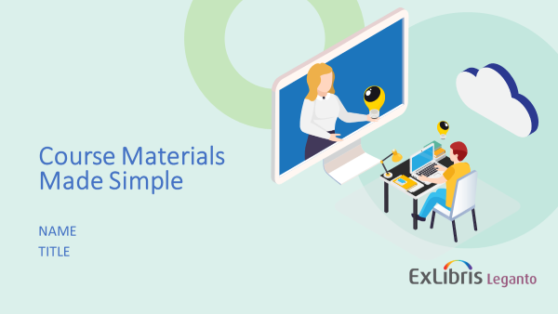 |  | My name is ---- and I’m excited to talk to you today about Leganto, which is a tool that makes it easier to set up and maintain your course materials in the Learning Management System. Many instructors have shared how hard it is when you’re continually asked to give up more and more of your time for the job. And I’m not talking about the time you spend putting lessons together, the time you spend teaching, or the time you spend with students.  I’m talking about the time you spend setting up and maintaining your course via the Learning Management System, the time you spend recording grades, staying up-to-date with university policies and research trends, and this is on top of all the committee work you do, department meetings you attend, professional development work you complete , and time you spend advising, mentoring and teaching students. Simply put, there aren’t enough hours in the day!
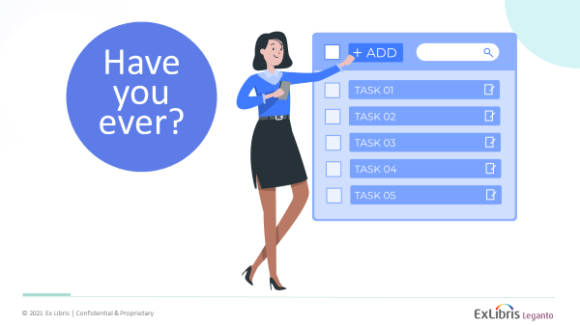 |  | I’m sure you all can relate to this, but to kick us off today, I would like to start by bringing up a few questions about how you currently work with course materials and share them with students.
 |  | - Have you ever had to dig into the various modules of your Learning Management System to reshare a resource you had previously shared with your class?  - Have you ever had a student tell you they didn’t complete an assignment because they couldn’t find it in the Learning Management System or didn’t realize it was due?  - Have you ever wanted to throw your computer out the window because organizing your course in the Learning Management System was difficult or simply took too much time?  - Have you ever wondered how (or if) students are engaging with the resources you’ve shared with them?  - Have you ever wished that you could have everything ready for next semester in just a few simple steps?  If you’re anything like the instructors that I have been talking with, the answer is “yes” to all these questions. Instructors often share they wish there was an easier way to locate resources, organize their courses, communicate student expectations, understand student engagement, and streamline semester prep each academic year.  So how do you provide a great learning experience for students without sacrificing yourself?
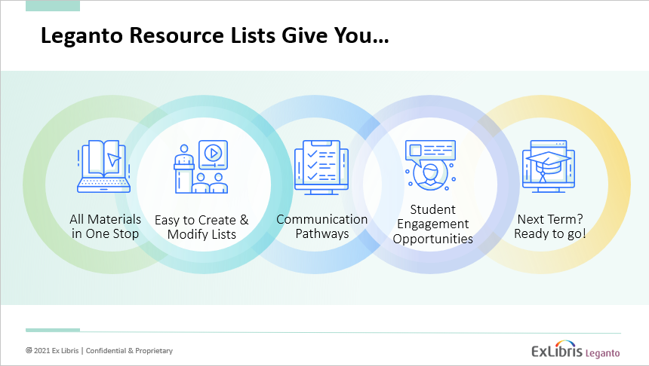 |  | Leganto can help with this, and this is what I would like to share today. Leganto is a tool that gives you…  - All course materials in one stop----Include all kinds of material types from all sources in one list – easy for students to find right from your course site!  - Easy to create and modify lists of course materials--search the library collection, add from web content, and upload your own files. Incorporate a variety of materials into your courses and organize your list in a way that best meets your students’ needs.  - Communication pathways--by using due dates, tags, and notes, you can organize and annotate references to ensure that your expectations are clear as well as consistent and predictable across courses for students.  - Student Engagement Opportunities—via analytics, see how students are engaging with resources and, if you like, enable discussions & let them suggest additional content.  - The ability to streamline semester prep each academic year. Create your list now, then easily duplicate it next term and make any additional adjustments you like.  Leganto won’t take away all your tedious tasks, but it can really save you time in setting up and maintaining your course materials in the Learning Management System and provide a great learning experience for students.
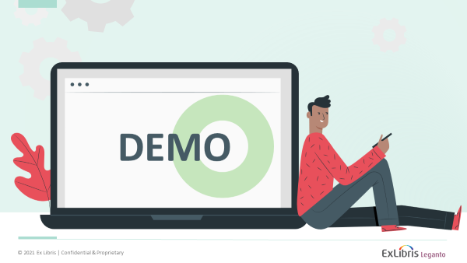 |  | On that note, I’d like to switch gears and show you how Leganto works.  Actions: log into Learning Management System, select course, click link to access Leganto/resource list
TOPIC | DEMO SCRIPT |  | EXAMPLE(S)
Reading list overview | We’re now looking at the tool and you’re able to see that I have a single list that enables me to compile and share all my course resources with students in one spot. Within each section associated with the list, you’ll notice that I’ve made a variety of different resources available —reference entries, book chapters, articles, PDFs, PowerPoints, videos, and more. You can provide all types of resources to your students in a single list organized in a way that matches the way you organize and teach your courses.  Via notes, tags, and due dates I can communicate my expectations to students for individual items within the list, (point out a specific citation that uses notes, tags, and due dates to communicate expectations). |  | -Scroll to provide an overview of the entire list.  -Select first section and scroll to show different examples found within single section.  -Select single citation that communicates expectations via notes, tags, and due dates.
-Add materials using CiteIt | Now, let me show you how easy it is to add new items to the list. Today, when you find a new resource that you want to share with students, what do you need to do? You probably bookmark it, but then you need to log into the Learning Management System, find the right section in your course, open it up for editing, type in the details of the item, paste in the link, then check it to make sure everything worked.  I would like to show you what this process looks like with Leganto. Let’s say that I’m just online doing some research and I find a resource or two that I would like to share with my students. I don’t need to do any of the things that I just mentioned, and I don’t even need to be in the Learning Management System at all. Instead, I simply use the CiteIt tool, which will quickly pull any web-based resource into my course. I can simply click on this button here (add video via CiteIt) in my browser, and very easily add this to my list of course materials. It pulls in the relevant information for me and I can specify where I would like the resource to go. I can even add a note to my students from here, and then I simply add and close. I can continue to add as many resources from the web that I’d like.  In addition to being easy to use, the CiteIt tool matches your course resources with the library collection. This means that your students will be able to easily access all of the resources that the library already pays for, potentially millions of resources which are free to your students. This includes Research databases, journals, books, videos, and more. |  | -Add one or two resources to first section via CiteIt  Article Example: https://link.springer.com/article/10.1007/s10746-021-09572-9  Video example: https://www.youtube.com/watch?v=1A_CAkYt3GY
-Add materials via library search | I do have other options for adding resources to my course. If I click on the “add” button, we can explore a couple of options together. I can search the library collection for specific titles, authors, resources, topics, etc. This enables me to easily drag and drop the resource that I would like to add to my course (search for and select specific item and add to reading list). |  | -Add one specific book, chapter, article, etc. to section one.  Search information: Philosophy of Religion or  Neville, R. C. (1995). Religions, philosophies, and philosophy of religion. International Journal for Philosophy of Religion, 38(1-3), 165.  Check your example in advance to confirm your library has a resource you can add.
-Add materials via file upload | If you have files that you’d like to include---PDFs, PowerPoints, etc.—you can easily add these files from your computer to Leganto, too. (drag and drop file) You can easily add all types of resources to a list. You can also see that as I added this resource, Leganto pulled information from the file as well. With Leganto, the process of creating lists and sharing materials with students is easy and saves time. |  | -Add one specific file by dragging and dropping file into place.  Sample file: Something new under the sun
-Modify and share lists | It’s also easy to modify lists once they’ve been created. If I want to adjust my list, I can simply drag and drop resources to where I’d like them to be, too (demonstrate how to move citations within list). When I’m ready, I can publish the list to share it with my students. And if I have any questions along the way about how to do anything, I can click on this question mark icon for help with specific tasks.  As you can see, it’s a flexible tool that’s easy to use, but you should know that this has also created a list that I can use outside of the course. We’ve started in the Learning Management System, which is of course a good place to start, but I can also pull this information out and use it in different ways. Perhaps you want to share this list with a colleague (“Shareable Link”) or export this list (“Export”) to add it to your CV or to update your syllabus. I can share this with my students easily, but also do other things with it. |  | -Move citation(s) within section.  -Click to show “Create a Shareable Link” and “Export” options.  -Click on question mark icon and show help
-Showcase the student experience | So Leganto makes the process of working with course materials much easier for you, but it also provides a great student experience (Show student view).  Students can see all their course materials here in a single list. While you do have different options to share resources—for example, you can link to specific sections of the list within the course itself—making all resources available in a single list can help students understand what your expectations are and where to find their readings.  If students want to go back to something they missed, or want to re-read something, they don’t need to dig through all the weeks of your course. They simply click on the link here to see all the resources. Mostly, we want to make sure that they do find it—that students don’t have any excuse not to do the readings.  They can view the full list (scroll to show full list), or search the list or filter it (click to show filter option), for example, only to the essential items (briefly show filter options for list) or the one’s they haven’t already read. Students can track their progress along the way by marking items as done.  You can also view the usage of these course materials (Switch back to instructor view). |  | -Show student view.  -Show filter options for list.
List Analysis | Via the analytics available in Leganto (click the list analysis icon), you can see information regarding how students are engaging with the different resources that you’ve assigned. What are students doing? Are they clicking through the full text? How many students have marked each item as done? You can see this information at any point in the course, and after the course is over. |  | -Click the list analysis icon
Rollover | And finally, the last thing I’d like to mention, is that there is an easy rollover process, so when it’s time to teach this course again, you can just roll this list over, make any changes you need to make, and you’re ready to go in a matter of clicks (show where “duplicate” option is located).  Alternative script:  And finally, the last thing I’d like to mention, is that there is an easy rollover process. The library can rollover your lists from one term to the next so when it’s time to teach this course again, you will just see your previously list and you can make any changes you need to make. |  | -Click to show “duplicate” location  *Please note some institutions may do bulk rollover
 |  | I know that many of you have already spent quite a bit of time setting up your courses and adding links or uploading files, and I know that the idea of switching to something new and unknown may sound daunting. Nevertheless, once you start using Leganto you’ll find that it’s easy to learn and easy to use. I think you’ll also find that the amount of time it takes to add resources to your course is significantly less than what you’re used to when working with the Learning Management System, so you can focus on the more impactful parts of your job. Now, I would like to open the floor for any questions you may have. I would also welcome your initial feedback at this time—what did you think?  As a follow-up to today’s session, I will be emailing you a list of resources available to assist you with using Leganto. The resources are easily available on our webpage, and I will send you the link for that as well.  If you have any questions and/or would like to discuss this great tool in more detail, please reach out to me directly. Thank you!

